Humason

Imaging Automation Front End for TheSkyX Professional on Windows 10 Desktop

V 4.0

**Overview**

Humason is a Microsoft Windows application that automates imaging configuration, sequencing and control using the functionality of the Software Bisque TheSkyX Professional Edition observatory control software and Paramount telescope mounts. Humason provides device configuration and control for camera, guider, filter wheel, focuser and rotator. reHumason is designed to run “set and forget” for a full night’s imaging activity from powering on an observatory just after dusk to powering it just before dawn.

**Common Session Work Flow Model**

To image each night, a user would normally run through the following steps:

* Pick one or more targets for the night with names, framing and guide star position.
* Determine exposures, filters and repetitions needed for each target and time frame.
* Open the dome, turn on dew heaters and fans, home the mount, cool the camera.
* Calibrate focuser, guider and rotator position for the session.
* For each target, set rotation, run through its sequence, meridian flip (and rotate) when needed, mind to the autoguiding.
* Collect flat calibration frames as needed for all rotation positions.
* Shut everything down and close up.

By in large, steps 3 through 7 are set up and run the very same way for every session, and step 2 rarely changes for most sessions as well. So, Humason is intended to provide enough of the configuration information and automation functionality to run TSX without intervention from step 3 through 7. In conjunction with the Image Planner application, it provides an interface for easily choosing and framing targets for that hands-off automation to execute.

As such, the first, and primary, assumption is that TheSkyX will suffice for nearly all hardware management functions. No other focusing, guiding, rotating or imaging automation software should be needed so it is not supported. The only non-Software Bisque automation supported is Optec FlatMan and AAG CloudWatcher which have no TheSkyX equivalents (at this time). A related requirement is that Humason works only with a Software Bisque Paramount mount. There are a few functions, such as side of pier information, that Humason utilizes which may or may not be available with other mounts.

The second assumption is that a user will configure and hone his system using the internal capabilities of TSX. Humason does not really attempt to disguise any usage complexity within TSX. Configuration and optimization of the mount (PEC and T-Point), camera (Image Link), filter wheel, focuser (@Focus2 or @Focus3), guider (Direct Guide and AO) and rotator are all mastered within TSX and should require little if any attention during successive imaging sessions.configured and mastered within TSX, although those configuration parameters may then be duplicated in Humason.

The third assumption is that once an imaging scheme is developed, a user rarely changes much other than to adapt to the imaging time available for a session. That is, filter order and sequence, exposure time, delays, and most other imaging parameters remain constant target to target, night to night. This assumption implies that a user should only have to pay attention to those elements that that change and use a common template for everything else.

The fourth assumption is that a user is willing to give up a few minutes of imaging time to avoid a whole night of babysitting. This means that Humason carries some overhead for precision slews, plate solutions and recalibrations in order to preempt potential problems with focus, guiding and framing during an imaging session.

**Humason Operation**

At its core, Humason creates and manages two types of data files: Session Plan file and Target Plan file. A Session Plan file contains all the information common to using TSX to image over a night from start up to shut down including targets to be imaged. Once a routine is established for a user’s observatory, a Session Plan rarely changes night to night other than the start up time and targets to be imaged.

A Target Plan file contains all the information specific to imaging one target using TSX including focusing, guiding, imaging and image calibration. A user can create any number of Target Plans in preparation for imaging, then schedule only those wanted for a given night’s session. Humason has a special default Target Plan (“Default.TargetPlan.xml”) that is used as a template when any new Target Plan is created. The user can modify this template at any time by simply overwriting the default target plan with another reconfigured plan (see Target Tab).

Humason runs as a Windows process, interacting with TSX through the run-time COM interface and utilizing a set of XML data files for configuration and run-time management. TSX is responsible for interfacing to all device drivers, except the optional FlatMan and AAGCloudWatcher hardware.

The Session Plan datafile and the Target Plan datafiles and well as captured images are stored in the user Documents directory in a folder called “Humason”. Images are stored in another subdirectory called “Images”. Log files are stored in a subdirectory called “Logs”.

In managing these data files, the Humason user interface is organized into functional blocks in the form of a base window with eight tabs. The organization represents a rough workflow for common configuration, target planning and sequencing activities.

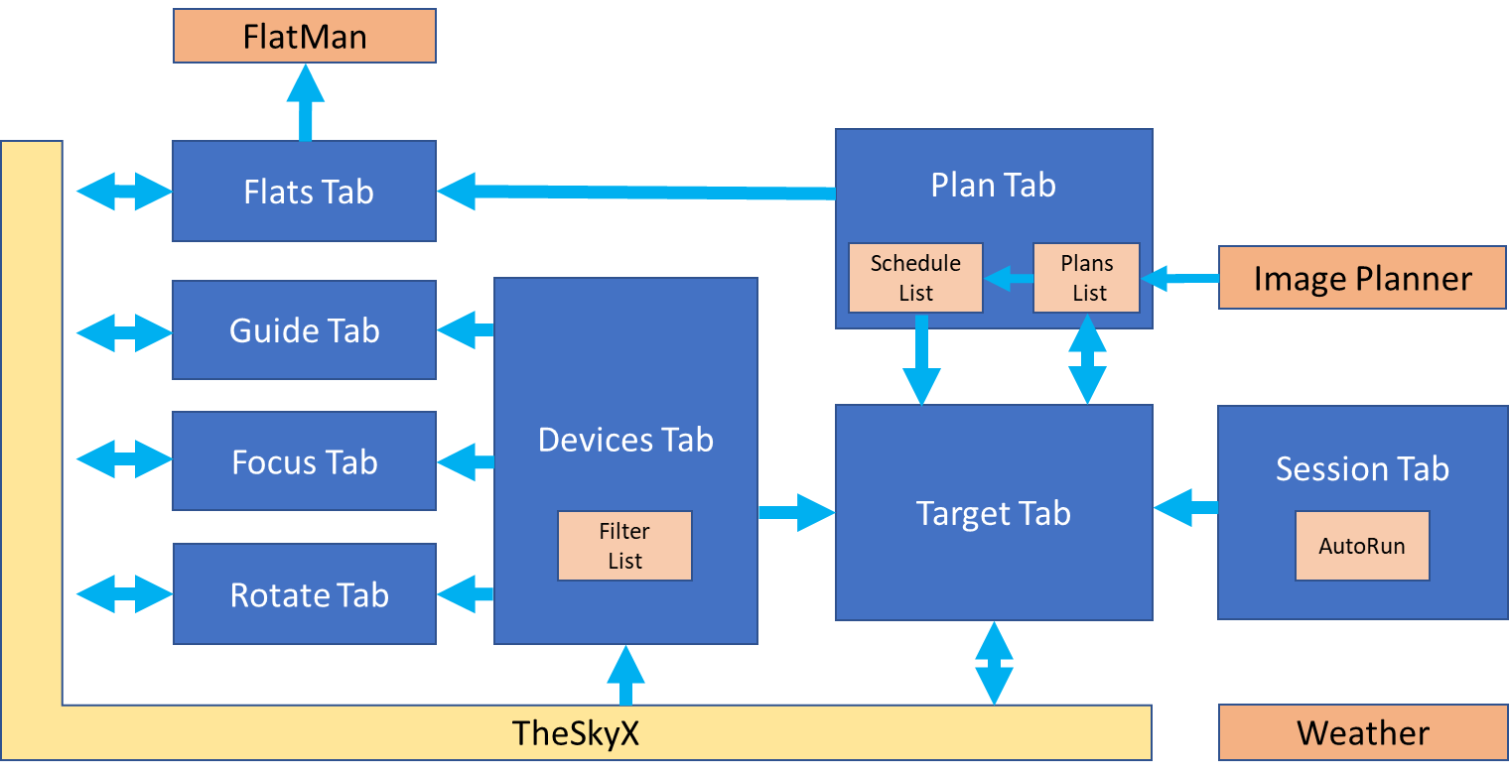

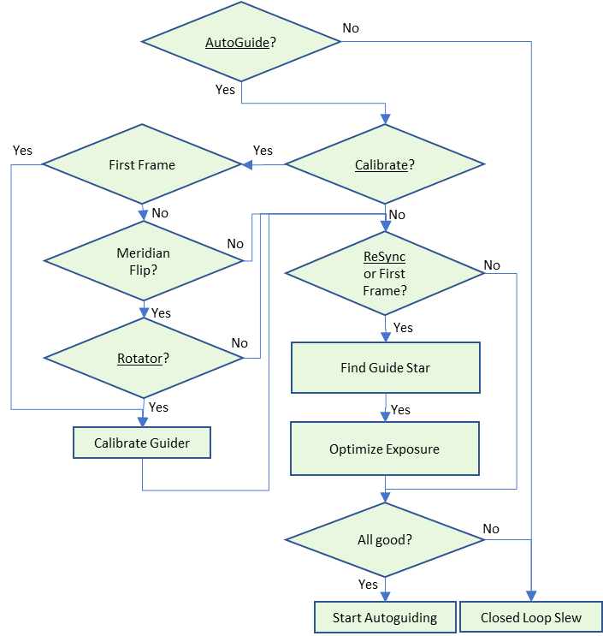Autoguiding

Humason allows for the configuration of several approaches to guiding, including unguided as shown in the autoguider flow chart. Humason runs through this decision process before imaging each frame (configuration parameters are underlined).

If AO is selected (not shown), then both Direct Guide and AO are calibrated (Calibrate Guider process), and AO is enabled for guiding (Start Autoguiding process). Note that calibration is always performed after a meridian flip if the system is using a rotator.

If Dithering is selected (not shown), then Humason will change the guide star coordinates slightly and randomly just before Start Autoguiding. This causes the guider to re-center the guide star image just a bit in the first few seconds of guiding.

If AutoGuide is not enabled, then Humason will automatically perform a closed loop slew to re-center the frame before each image.

**Usage**

Presumably, a new user starts with getting acquainted with TSX stand-alone. Here the user would master and tune the following functions in possibly the following order:

* Mount control and slewing, then Park set up
* Imaging, Focusing, then AtFocus2 and/or AtFocus3 calibration
* Image Linking, Closed Loop Slews, then T-Point calibration
* Guider calibration, Autoguiding, then PEC calibration
* Dome control (if any)
* Rotator control (if any)
* FOVI set up and configuration
* Taking Flats

Once the user has all TSX functions performing well, then Humason can be brought into play. Generally, the first step would be to configure Humason Options, then restart and fill in the Rotator, Guider, Focus, Device, Session, then Flats Tabs. During this process, TheSkyX and Paramount must be powered up and connected so that Humason can download various information such as the filter set up while configuring.

Four tabs, Flats, Focus, Guide and Rotate, provide for some initialization, calibration and test operations on their respective devices. Normally these tabs would only be used if trouble-shooting some specific problem but can also help verify that certain operations are working correctly.

The Devices Tab configures which devices are to be used in the imaging stack and operation options. Usage options for the Camera, Filter Wheel, Focuser, Guider and Rotator are set up here.

The Session Tab sets up for an external script or executable to be run at launch, imaging start-up and imaging shutdown. The user can also choose to monitor weather conditions and operate a dome (through the TSX Dome Add-On).

The Flats Tab sets up for flat calibration frames to be taken: dawn, dusk or FlatMan. When sequencing, Humason automatically keeps track of what flat frames are needed for calibration and uses this information for acquiring them.

After completing configuration, most imaging sessions only require preparation on the Plan and Target Tabs – the Plan tab for choosing and framing targets, the Target tab for defining the image sequencing of those targets. The remaining tabs can be largely ignored for each night’s run.

Target Plan definition is accomplished with the Plan Tab. A selection can also be made in the Plan tab by either uploading a target already selected in TSX or typing a name in the Plan tab for TSX to look up. Once a target is selected, it appears in a list on the Plan tab and can be loaded for adjustment of framing and position angle, and for setting up its imaging. The Plan tab also supports the adjustment of image position and position angle using the TSX Star Chart. Targets are selected from this list and moved to the Schedule list on this tab for each night’s session. Targets are also “loaded” off this list for configuration of their imaging sequence from the Plan List.

Once loaded, Sequence set up for each target is accomplished on the Target Tab.

**Tab Descriptions**

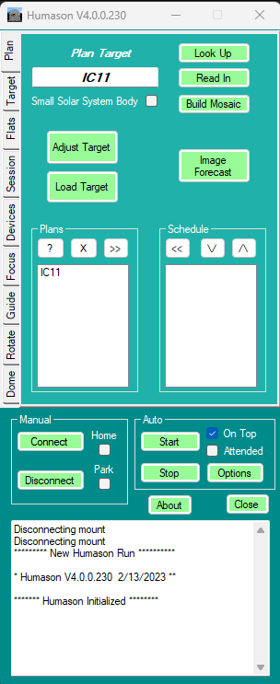**Humason Form**

The bottom of the main form is for initiating or terminating a night’s imaging session, once devices have been configured, targets have been selected and imaging sequences defined. The form also has buttons for Connecting and Disconnecting TSX devices when trouble-shooting device issues.

Connect: Connect all TSX devices (automatic with Start).

Disconnect: Disconnect all TSX devices (automatic with Close).

Home: Cause TSX to home the mount upon connection.

Park: Causes TSX to park the mount upon disconnection.

On Top: The Humason application window will always show over other windows.

Attended: Disables Shut Down scripts, if enabled.

NS Journal: Removed in Version

Start: Initiates imaging the Scheduled Target Plan List (See Plan Tab):

* If AutoRun (Session Tab) is checked, then Humason waits until the Staging Time (if enabled) and runs the Staging executable.
* If AutoRun (Session Tab is checked, then Humason waits until the Start Up Time (if enabled) and runs the Start Up executable. Lastly, Humason if the initial target is within 10 minutes of the meridian, then it will wait it out.
* For each target in the Schedule (Plan Tab), Humason loads the target data and initiates imaging. If enabled, camera focus, autoguider calibration, and rotator calibration run before each new target, Temperature, Weather and Shutdown Time are checked and acted on before each image.
* If Weather Conditions are unsafe, the dome shutter will be closed (if enabled) and the mount parked until a safe condition is posted.
* If AutoFocus is set and the temperature changes by more than the value set in the Devices Tab, then Humason causes TSX to make an autofocus run.
* If Shutdown Time is exceeded then Humason runs the Shutdown executable (if enabled) and disconnect the TSX devices.

Abort: Terminate current imaging run.

Options: Open a window for setting up general Humason application window options (see description).

Close: Disconnect TSX devices and close Humason

Reader Strip on the bottom of the window contains activity output from Humason as it completes various tasks. This information is also saved to the Log File (See Resources).

**Plan Tab**

In the Plan tab, Humason works with TSX to assemble a list of targets for imaging. Normally, the companion application Image Forecast is used to preview and acquire targets, but not necessarily.

Target field: Name for potential target. Target names in Humason are always capitalized. Get used to it.

Look Up causes Humason to build a target based on the name in the Target field. If Look Up is selected with an empty Target name, Humason will use the target name currently set in the TSX Find function.

Read In causes Humason to poll TSX for the target name and information that is currently displayed in the TSX Find function.

Build Mosaic generates a set of target plans based on the currently loaded target plan and the TSX Mosaic Tool. Upon selection, the button will turn red and display “Clipboard Ready”. The user must open the Mosaic Tool in TSX (*Tools -> Mosaic Grid*), configure the mosaic in the *Geometry* tab, then select *To Clipboard*, then *Clear Mosaic Grid* in the *Advanced* tab, then close the tool. Clicking on *Clipboard Ready* will generate the mosaic’s target plans under the plan names <target name.-<mosaic set>-<mosaic index> and update the Plans List.

Image Forecast launches the Image Forecast application for previewing target information and generating target plans.

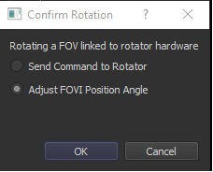Adjust uses TSX to reposition the frame and rotation of a target image using the grab and rotate Star Chart tools. Upon completion of the adjustments, the button is clicked again to save to the currently loaded target. The target name will remain the same, but the RA/Dec and PA for that target will be changed accordingly.

*TSX FOVI must be configured correctly and accurately for this feature to work. If the FOVI does not show on the star chart, then edit the FOVI such that the “Reference Frame” is “Center of Star Chart”.*

*Note: Upon completion of a rotation reposition, “Adjust FOVI Position Angle” the FOVI only should be adjusted, not the rotator.*

Load Target uploads the target data for the selected target in the Plans List so it can be adjusted or reviewed in TSX.

Plans List is a list of the target names for all currently saved target plans. “?” refreshes the list. “X” deletes the selected target plan. “>>” moves the selected target plan to the Schedule List.

Schedule List is the list of targets to be imaged by Humason during this session. When started, each target is imaged according to its sequencing configuration in turn, topmost first. The “<<” removes the selected target from the list. The “\/” moves the selected target down in the list by one position. The “^” moves the selected target up in the list by one position.

**Target Tab**

The Target Tab supports set up details for imaging a single target. The Target can be loaded from the Plan Tab or directly from TSX by entering a target name. If the target has been previously set up, then the imaging fields will be populated from that target’s plan. If not, the fields will be populated from the Default plan (see Plan Tab).

Target identifies the name of the current target.

Exposure sets the time (in seconds for all images for this target)

Loops sets the number of repetitions for the filter set selected.

LRGB Ratio sets the number of Clear filter images to be taken for each set of the other filters. If there is only one filter configured (see Devices tab), then this ratio will be automatically held to 1.

Delay sets the amount of time (in seconds) that for waiting immediately before each exposure.

RA sets the Right Ascension for the image. This may be different from the cataloged target location depending upon Adjust.

Dec sets the Declination for the image. This may be different from the cataloged target location depending upon Adjust.

PA sets the Position Angle for the rotator, if rotation is enabled.

Adjusted indicates whether the image has been adjusted from its catalog location. If clicked, then the Adjust procedure is followed to do that adjustment (See Plan Tab).

Enable Flats Session: if enabled then Humason will generate flats information and run a flats session at dusk, dawn or with FlatMan at session completion. See Flats Tab.

Update causes new values to be calculated for the Start, Flip, Done, Transit, At<30, and Dawn fields. This calculation is based on the entered Start time and the image capture fields above. In addition, Humason keeps track of the average amount of time spent between frames for the last run, i.e. plate solving, starting autoguiding, refocusing, rotating, flipping, etc. This average will added in to the overall calculation

Save As Default makes the currently loaded device, session and sequencing data the default for any new target added to the target data base.

Start is the date and time that imaging of the target is to start. By default this is the start time for the loaded target plan. Double-clicking on this form will reset start time to current time.

Flip is the calculated time of day that imaging of this target would require a meridian flip.

Done is the calculated time of day that imaging of this target would complete.

Transit is the calculated time of day for the next target transit. This may be different from Flip.

At < 30 is the calculated time of day that the target altitude drops below 30 degrees.

Dawn is the calculated time of day for the next dawn. The date can be verified by clicking on the down arrow in this field.

Progress Bar shows the fractional completion of the imaging session for this target.

**Flats Tab**

The Flats Tab configures TSX and, preferentially, FlatMan for taking flats before or after an imaging session. During imaging, Humason keeps track of what filters at what position angle (if rotation is enabled) have been used during shooting the targets. Upon completion of the imaging session, this list is automatically processed through to make flats: the mount will be pointed at the FlatMan screen (or sky apex), FlatMan launched and lit, brightess/exposure adjusted to target ADU and camera rotated to desired PA and flats taken. The tab also supports manually making flats any time using Make Flats and Take Flats. Humason is really designed to take advantage of FlatMan at the end of an imaging run rather than dusk or dawn flats. If dusk flats are wanted, then they should be configured manually using this tab, as Humason determines what flats are needed during the imaging run, not before. Also, take care that, if AutoRun is used, the ShutDown time is set allowing for the time to make flats. Default of ShutDown is dawn.

Source: FlatMan, Dawn or Dusk picks the source for taking flats.

Reps sets the number of flats to take of each configuration.

Target ADU sets the target range for flat exposure. The exposure time for dusk or dawn will be adjusted to get within 10% of this value. Brightness for the FlatMan may be adjusted as well, if used.

Flip determines if the mount should be flipped for dawn and dusk flats can be taken for both sides.

Rotate determines if flats should be taken at opposite rotation angles (if rotation enabled).

Rotator PA (West) determines at what angle the rotator is at for a West side of pier.

Make Flats creates a set of instructions for creating flats according to the current filters, PA, Reps, Flip and rotation parameters.

Take Flats is really designed to be used with FlatMan, but can be initiated before “Dusk” or “Dawn”. It causes Humason to service the set of requested flats immediately. If “Dusk” or “Dawn” are selected, then Humason will take an image every minute until it is sufficiently dark (or light) that the Target ADU can be achieved with Filter 0.

Clear Flats deletes the list of currently requested flats.

Manual Setup causes the procedure to pause after staging the imager in order that the user can position the FlatMan panel. If selected, the procedure will pause again after completion of flats so the that FlatMan panel can be secured before parking the telescope.

FlatMan: Com Port sets the com port for the FlatMan hardware.

FlatMan: Exposure sets the initial exposure (in seconds) for the flat.

FlatMan: Brightness sets the initial brightness for the flat.

FlatMan: FlatMan East of Pier? Sets whether the mount is East of Pier when pointing at the FlatMan screen. This is used for choosing at which PA the rotator will start.

FlatMan: Stage causes the mount to move to a user configured position “My Flat” in TSX and tracking turned off.

FlatMan: Turn On manually turns the FlatMan light on.

**Session Tab**

The Session Tab configures information that applies equally to all the targets imaged in a session. The screen sets up for Auto Run, Weather and Dome features.

Use Auto Run determines if Humason will run external scripts or executables at specific events during the session. Selecting Auto Run will open the Auto Run Configuration screen below.

At Session Start Up Time: Enable Script/App will cause Humason to launch the script or application configured in the respective AutoRun Configuration dialog at the beginning of a session (Main Form: Start).

At First Target Plan Starting Time: Enable Script/App will cause Humason to launch the script or application configured in the respective AutoRun Configuration dialog at the start time of the first target loaded (Target Tab: Start).

At Session End or Dawn: Enable Script/App will cause Humason to launch the script or application configured in the AutoRun Configuration dialog after the completion of the session (Target Tab: Done) or at first daylight (Target Tab: Dawn) whichever comes first.

Minimum Altitude sets the altitude limit for an imaging sequence calculation (See Target Tab).

Check Side Of Pier interrogates the mount to get the current side of pier for testing purposes.

Enable Meridian Flip gives permission to automatically execute a meridian flip when conditions warrant. Do not enable unless Humason is able to determine the Side of Pier correctly.

**AutoRun Configuration**

The AutoRun Configuration screen uses dialogs to set the location of the scripts or executables to be run with AutoRun times. Although the browser dialogs will show complete file paths, the respective fields will only show the filename.

Enable determines if Humason will execute the script at the given session time.

**Devices Tab**

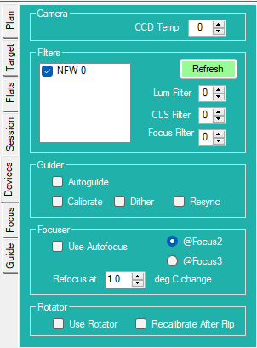The Devices Tab is the primary screen for configuring which devices are to be used and in what way. Devices include primary camera, filter wheel, guider, focuser and rotator.

Camera: CCD Temp sets the temperature at which to operate the camera (in degrees C).

Filters: Refresh prompts TSX for a list of filters that are configured for the filter wheel.

Filters: List is the last supplied list of filters configured for the filter wheel by TSX. Filters are listed by TSX name and filter wheel number (zero-based). Each filter must be checked if it is to be used in the imaging sequence.

Filters: Lum Filter the zero-based number of the Luminescence filter in the filter wheel. This filter will be for the “L” in the “LRGB” ratio.

Filters: CLS Filter the zero-based number of a filter in the filter wheel. This filter will be used for plate solving and Closed Loop Slews.

Filters: Focus Filter sets the zero-based number of the filter to be used when autofocusing with @Focus2 or @Focus3.

Guider: Use AutoGuide enables autoguiding while imaging.

Guider: AutoDark enables automatic dark image reduction on the guider camera (recommended).

Guider: Calibrate causes the autoguider to be recalibrated initially and after any rotation.

Guider: Dither causes dithers to be inserted before every image exposure.

Guider: Resync causes autoguiding to be suspended then restarted between images. If not checked, then autoguiding will continue through all images until a move or rotation.

Focuser: Use Autofocus enables autofocus to be performed initially and after temperature changes (see Refocus At).

Focuser: @Focus2 selects TSX @Focus2 for autofocusing.

Focuser: @Focus3 selects TSX @Focus3 for autofocusing.

Focuser: Refocus At determines the shift in temperature (in degrees C) required to initiate a new autofocus run in TSX.

Rotator: Use Rotator determines whether the rotator is to be used for achieving target PA’s and flats.

**Focus Tab**

The Focus Tab is primarily a tool to test focuser functions.

Preset Focuser opens a dialog to load a previously acquired set of positions for filter offsets for the focuser in the form of a focus data file.

Run @Focus2 runs @Focus2 at the current location using the TSX autofocus configuration settings such as star selection at the initial exposure set by Exposure after selecting the filter set by Focus Filter.

Run @Focus3 runs @ Focus2 at the current location using the TSX autofocus configuration settings such as star selection at the initial exposure set by Exposure after selecting the filter set by Focus Filter.

Focus Filter sets the filter to be used for autofocus in TSX.

Exposure sets the initial exposure to be used for autofocus in TSX.

**Guider Tab**

Humason performs an extensive set of guider operations beyond the basics provided by TSX. Humason takes a guider image, finds an optimal guide star (without neighbors and away from frame edge), adjusts the exposure to be close to a set ADU. In addition, the tools allow the user to calibrate in place or automatically select and slew to a decent guide star in the locale for calibration. These values will then be used during the actual imaging session, as needed.

Use AO enables AO for guiding.

Default Guide Camera Exposure sets the initial exposure for the guide camera image, before optimization.

Minimum Guide Camera Exposure sets the minimum exposure that the guide camera will use for optimization.

Maximum Guide Camera Exposure sets the maximum exposure that the guide camera will use for optimization.

Total Guider Cycle Time sets the duty cycle for guiding repetitions.

Guide Star Target ADU sets a target value for guide exposure optimization.

Edge Margin (pixels) sets the minimum distance in pixels from the edge of a guider image for picking a guide star.

Find Guide Star takes an runs an algorithm that picks the “best” guide star from the guider image. The selected guide star will be no closer to the edge of the image than Edge Margin and have no visible neighbors within the trackbox size. The Guide Star coordinates are displayed in the box to the right.

Optimize Exposure runs an algorithm that finds an exposure time, somewhere between Minimum and Maximum Camera Exposure settings, that gets closest to the Guide Star Target ADU.

Binning sets binning for the guide camera.

Calibrate prompts TSX to run a guider calibration. If AO is set, then AO is calibrated as well.

AutoCalibrate finds a bright star near the current pointing position, slews to that location, adjusts the exposure such that the star is not saturated and calibrates.

X Sec is the number of seconds (Relay Mode) or arc seconds (Direct Mode) for calibration in X direction.

Y Sec is the number of seconds (Relay Mode) or arc seconds (Direct Mode) for calibration in Y direction.

Subframe causes a subframe 3x the size of X Sec and Y Sec to placed around the guide star location for calibration. This subframe will mask off nearby stars and hot pixels. This feature relies on having a properly constructed FOVI for the guide camera. See AtGuider2 documentation for details.

Start Autoguiding loads the relevant set up parameters and tells TSX to start autoguiding.

**Recommended TSX Guider Set Up for @Focus2:**

**Rotator Tab**

The Rotator Tab contains functions for exercising and debugging a TSX-managed rotator.

Plate Solve takes a camera image and runs a TSX Image Link to determine Image PA, Rotator PA, FOV PA and Rotator Offset.

Exposure (sec) sets the number of seconds for image exposure in plate solving.

Image PA is the position angle determined by Image Link.

Rotator PA is the position angle reported by the rotator.

FOV PA is the position angle calculated by TSX for the FOVI.

Rotator Offset is the offset calculated by TSX for the rotator.

Rotator Direction is the direction (CW or CCW) calculated for the rotator after performing an Initialize (below).

Initialize determines the direction rotated when driven to a positive value. Humason performs a plate solve for Image PA, tells TSX to rotate in a positive direction, performs another plate solve for Image PA, then determines if the effective rotation was in a CW or CCW direction.

Check polls TSX to refresh the results for Image PA, Rotator PA, FOV PA and Rotator Offset.

Target uses the RA, Dec and Image PA of the current Target (See Target Tab) as coordinates for a Plate Solution. The results for Image PA, Rotator PA, FOV PA and Rotator Offset are updated accordingly.

Rotate To: Rotator PA causes TSX to rotate to the Rotator PA setting.

Rotate To: Image PA causes TSX to rotate to the Image PA setting, as calculated from the Image PA, Rotator PA, FOV PA and Rotator Offset fields.

**Dome Tab**

TBD

**Options**

The Options window allows a user to choose to enable (or disable) Power Management and Rotator functions as a whole. If disabled, the Tabs associated with these capabilities will also be suppressed.

Has Rotator enables the Rotator Tab. For Humason to use a rotator during a session, the Use Rotator check box on the Devices Tab must also be checked.

Has Weather Monitor enables the checking of weather conditions through an AAG CloudWatcher (or equivalent) data file. Upon checking, a dialog will pop up for setting a path to that file.

Has Dome AddOn enables the dome control, primarily used in conjunction with the Weather Monitor, but also to enable response delays after slews to allow the dome rotation to catch up before imaging starts in certain situations.

No Filter Wheel is checked when no filter wheel is configured for TSX, for example if a DSLR camera (OSC) is used. If checked, Humason will automatically configure only one “filter” called “NSW” and limit the LRGB ratio to 1.

Image Reduction sets the type of noise reduction to be applied to each type of imaging, None, AutoDark or Full Calibration.

**Requirements**

Humason is a Windows Forms executable, written in C#. The app requires TheSkyX Pro (Build 11360 or later). The application runs as an uncertified, standalone application under Windows 7, 8 and 10. Humason requires .NET 4.8.0 Runtime (<https://dotnet.microsoft.com/download/dotnet-framework/net48>)

**Installation**

Download the Humason_Exe.zip and open. Run "Setup.exe". Upon completion, an application icon will have been added to the start menu under the category "TSXToolKit" with the name "Humason". This application can be pinned to Start or Desktop if desired.

**Resources**

Support Files: Humason creates a folder in the user’s Documents directory called “Humason”. Within this directory all configuration and target files are stored in XML format. Humason also creates a subdirectory called “Logs” in which logs (in text format) are stored for each night’s imaging. Log files have a date-based naming style. Image Planner, if used, also stores it’s target data files in the Humason directory.

Image Files: Humason creates a subdirectory in the Humason folder called “Images”. Target images are stored in subdirectories named <date>_<target name> in a subdirectory “Data Files”. Individual images are stored in .fits files named

<filtername><targetname>_<PA><SOP>.<#>.fit

where PA is the position angle of the image in degrees and SOP is the side of pier (E or W).

Calibration Files: Humason stores flats files in the Humason Image subdirectory named <date> in a further subdirectory “Calibration Files”. Calibration .fits files are named:

<filtername><targetname>_<PA>PA<SOP>.<#>.fit

where PA is the position angle of the image in degrees and SOP is the side of pier (East or West).

**Support**

This application was written for the public domain and as such is unsupported. The developer wishes you his best and hopes everything works out, but recommends learning C# (it's really not horrible and the tools are free from Microsoft) if you find a problem or want to add features. The source is supplied as a Visual Studio project on GitHub (rrskybox/Humason).

**Usage Notes**

* External scripts or apps can be launched only at the start of a session (pressing the Start Button), at the start of the first target imaging (as set by that target plan) or at the end of the session (end of last target imaging or dawn). There is no built-in option to do something akin to launching an external script to open the dome slit an hour before starting to image the first target. Such delays would have to be written into a script/app to run at Session Start Up that would delay the action.
* How to launch a stand-alone script or application *At First Target Starting Time*.
* Select *Session Tab*
* Check Use *AutoRun* to open *AutoRun* Configuration window.
* Select *Browse* for *Start Up* file dialog
* Navigate to and *Open* script or application
* Uncheck *Wait* if Humason is not to wait until script or application exits.
* Select *OK* to close window
* Check *At First Target Starting Time: Enable Script/App.*
* Select *Target Tab*
* Enter time for *Start (Target Tab)*
* Select *Update (Target Tab)*

**Change Log**

1. Initial Functionality
2. …
3. …

4.0 TSX 64

Stuff to do sometime

* Predict initial exposure for a guide star
* Complete Journaling
* Image bank searches